LTD “Georgia Rent Car”

CAR RENTAL

**a g r e e m e n t**

Parties

**I/C _____________** (Hereinafter “**Customer**”), presented in the person of**_____________**, from one hand and transport company **LTD. georgia rent car I/C 402017811**, (Hereinafter **“ ”**), presented in the person of director **Zviad Mskhiladze**, from other hand, draw up the agreement as follows:

1. **AGREEMENT SUBJECT**
   1. Agreement subject is car rental service

**2. CONDITION OF CAR RENT:**

2.1 The Rental Company states that to the best of his knowledge and belief that above-described vehicle is in sound and safe condition and free of any known defects or faults which would affect its safe operation under normal use. Company must show all the dents and scratches which are on body and mark it on list.

2.2 The Renter states that he / she is physically and legally qualified to operate the above-described vehicle.

After marking all of defects on the car list all additional damages must be informed immediately to the insurance company.

In case of injury of the car case will be considered by insurance company.

If case will be not informed to the insurance company any injury will be paid by renter without any further explanation

**3. Final provisions**

3.1 The agreement governs under Georgia legislation.

* 1. Agreement comes into effect after it’s signing by authorized representatives of the parties and valid for one occasion only.

Car model:

Name of driver:

Driver ID number:

Passengers:

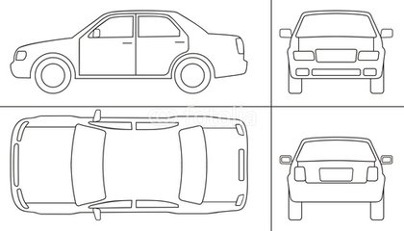

Departure date: Return date:

Total price:

Deposit:

Signature Renter: Signature Company:

All the drivers must be up to 25 years with valid driver’s license

Insurance contact: 571111222 Company contact: -----------------------